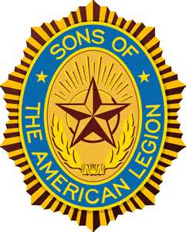
<Insert Post Name> SQUADRON XX
SONS OF THE AMERICAN LEGION

Fellow Members,

In a few weeks your membership in the Sons of The American Legion will expire and the benefits you receive will be discontinued. Along with this, we as an organization will have lost an important part of our family. You see every member makes a difference, whether you attend meetings or not, every member helps us support the ideals and principles of The American Legion.

Our membership dues assist in fighting for veterans’ benefits, by providing funds to the National Organization, who in turn keeps a staff in Washington D.C. and lobbies on behalf of our veterans. They also help support many children and youth programs both locally and nationally, Americanism programs, and Veterans Rehabilitation efforts.

I know that many of you have done an outstanding job in the past assisting the members of The American Legion with their endeavors, and I personally thank you for your contributions. Please pay your 2018 membership dues in the near future and continue to receive membership benefits. Your membership dues are explained on the enclosed renewal notice, a small price to pay considering the price that was paid by many of our parents and grandparents that served this country in the Armed Forces.

Send dues to: Sons of The American Legion
C/O <Insert Name>
<Insert Address>
<City>, <St>. <Zip>

Checks payable to: SAL Squadron XX

Amount: $XX

Thank You for your continued support,

<Insert Name>
<Insert Squadron Office>

